|  |  |  |  |  |  |
| --- | --- | --- | --- | --- | --- |
|  |  | | | | |
|  | |  | | | |
| Project: | | {Student Information Exchange }  CSE 5325 – Spring 2022  Project Management | | | |
| Module: | | COCOMO | | | |
| Deliverable: | | COCOMO Estimate Report | | | |
| Version: | | | [1.0] | Date: | [11/01/2022] |

Prepared by: {Saahil Anande, 1001855308}

TABLE OF CONTENTS

1. Introduction 2

2. Estimating Factors 3

2.1 Source of Lines of Code 3

2.2 Scale Drivers 3

2.3 Cost Drivers 3

3 Project Final Timeline and Cost Structure 4

4. Conclusion and Recommendations 5

Appendices 6

# 1. Introduction

This document's goal is to provide a cost estimate for our project, Student Information Exchange (SIE) , utilizing a cost estimation technique that makes use of the COCOMO II Model. A challenging phase of the software development life cycle is planning a project with associated cost estimates. We can determine the time needed to complete the project, the amount of effort needed in person-months, and the overall cost with the aid of cost estimate tools and cost estimation models.

Student Information exchange System is a web with corresponding android, IOS based application which allows the users of the application to exchange information efficiently and easily, keep track of users and their activites (posts, members), trading system which allow user to buy/sell items and seek, offer tutoring services. The project has tight schedules and the duration of the project is of three months.

The document gives a summary of several features , including the total amount of source code (SLOC) required to write the entire program, Scale Drivers, which paints a complete picture of the project's scope, and Cost Drivers, which calculates the project's effort and duration. The items on the list above help the project manager (PM) plan each phase of the project according to the model selected for the project (Incremental Model), navigate each step according to the estimate and expense allotted for them, and then move on to the next stage. We used Costar, a tool for implementing the COCOMO model, at this stage to determine the effort, timeframe, and cost necessary to execute the software project.

After the estimation is complete, it will help the project team to grasp clearly the most effective way to design the entire project by leveraging resources and effectively allocating money to each of them all at once and not compromising the final product's quality. A suggestion on the most effective method of planning, where to make changes to the planning activities to ensure that the final product is of high quality without compromising any factors, is provided based on the originally planned and estimated project budget/duration and comparing it with the current COCOMO estimation.

# 2. Estimating Factors

## 2.1 Source of Lines of Code

The following is the number of lines of code delivered as part of this project, A justification for the total amount of LOC is provided.

|  |  |
| --- | --- |
| **SLOC | Source Lines Of Code** | Value Chosen: 5000 |
| Justification: The code for the SIE system will have more than 5000 SLOC, but we can reduce it to 5000 SLOC with the aid of code optimization and component reuse. By creating components and reusing them, we will drastically reduce the amount of source code. Additionally, react-native will be used by the development team. Consequently, there will be a single code base for applications on both Android and iOS. | |

## 2.2 Scale Drivers

The following is the list of scale drivers, the values applicable to this project and a justification for each value chosen:

|  |  |
| --- | --- |
| **PREC | Precendentedness** | Value Chosen: Very high |
| Justification: The company appears to be aware of the project's objectives and has a lot of experience dealing with relevant technologies. Since some of the features such as Login/registration, payments, e-commerce trade and Searching are part of many projects and applications and Due to our team's familiarity with the project's development environment, precendentedness is set to a very high level. | |

.

|  |  |
| --- | --- |
| **FLEX | Development Flexibility** | Value Chosen: Low |
| Justification: The client's minimum functional requirements won't alter, there is little development flexibility. Additionally, the software must generally adhere to already specified criteria for external interfaces and client interfaces. We have already considered future requirements while requirement gathering and the development conditions are highly strict, and all changes require clearance. | |

|  |  |
| --- | --- |
| **RESL | Architecture/ Risk Resolution** | Value Chosen: Very High |
| Justification: We presumptively determined and verified that the focus on architecture, risk assessment, and risk reduction is consistent with a well matured process. Schedule, budget, and internal milestones are all listed, along with all significant risk mitigation such as database sharding and recovery techniques for database failure and pair programmer for personnel shortfall are already being considered. It will be necessary to address some of the factors, including lower cost/resource availability and hardware/software failure.In order to address these risks and be adequately prepared, additional emergency expenses reserves have been allocated to the overall budget, Thus RESL is chosen Very High | |

|  |  |
| --- | --- |
| **PMAT | Process Maturity** | Value Chosen: High |
| Justification: since the processes and methods used in SIE adhere to the agreed-upon measures like Schedule variance, Cost Performance, Active Users, and other metrics while maintaining the standard metrics and scope. The process is set up so that the project will proceed without significant setbacks and in an orderly fashion. The PMAT level is decided upon level 3 defined. | |

|  |  |
| --- | --- |
| **TEAM | Team Cohesion** | Value Chosen: Very high |
| Justification: The team size is small (5 members) and the team will be working closely together. All parties involved in the development of the product share a common understanding of it as well as communication. There exists a well-established trust relationship among everyone involves right from developers, testers, lead, manager to investors. Hence the team cohesion is Highly cooperative and Very high | |

## 2.3 Cost Drivers

The following is the list of cost drivers, the values applicable to this project and a justification for each value chosen:

**PERSONNEL COST DRIVERS:**

|  |  |
| --- | --- |
| **ACAP | Analyst Capability** | Value Chosen: High |
| Justification: we presume that the team's analysts are highly skilled in design and programming, diligent in their job, and able to collaborate effectively with other team members. Up to 50% of the system's design has already been completed. The development team has skilled design analysts who can examine the system's modules to ascertain exactly what requirements are required, and who are prepared to meet those requirements for the system going forward. Hence ACAP IS high | |

|  |  |
| --- | --- |
| **APEX | Applications Experience** | Value Chosen: very High |
| Justification: The company's senior software developers and project managers collectively have more than five years of expertise managing and implementing software products. While the backend database communication is carried out using Python, c# and the testing is carried out using Selenium WebDriver, the front end of the system is constructed using HTML, CSS, reactjs.and javascript The team's developers have already completed numerous similar projects employing the aforementioned technologies and have created high-quality applications. | |

|  |  |
| --- | --- |
| **PCAP | Programmer Capability** | Value Chosen: High |
| Justification: The project's programmers have excellent analytical, coding, and technical skills. Programmers are competent, effective, and meticulous. They have excellent communication and teamwork skills. The programmers in the project are highly capable of handling such projects and have extensive knowledge in app development. They have already delivered successful quality projects under the same technologies and are well experienced in it. Additionally, prior to start of the project 30 days training was given to each developer specific to this project. Hence PCAP value chose is high | |

|  |  |
| --- | --- |
| **PCON | Personnel Continuity** | Value Chosen: <name your value> |
| Justification: The process maturity is at a reasonable level 3, the procedures are defined and understood, and the company is still quite new to the market. Furthermore, throughout the previous few years, the company has been producing nominal turnover. There are no plans to cut costs and lay off employees as a firm. Additionally, we presume that a single development project team of dedicated employees has been assembled for this project, and that the percentage of employees that depart and are replaced by new employees is quite low. | |

|  |  |
| --- | --- |
| **PLEX | Platform Experience** | Value Chosen: High |
| Justification: The project's developers have more than five years' worth of experience building applications, The web application is build using react-js while the mobile part of the application is build using react-native allowing to reuse same components for both android ,IOS and web browser projects reducing the numbers of lines of code required for different projects whilst using javascript under the hood as programing language. Also the testing team is working with selenium and has three years of expertise in it. | |

|  |  |
| --- | --- |
| **LTEX | Language and Tool Experience** | Value Chosen: <name your value> |
| Justification: The development team intends to employ HTML, CSS, JavaScript, ReactJS, React-Native, Node JS, and MySql DB to query data from the database when creating this application. Docker and visual studio code are the programming tools. Team members have at least five years of experience with these languages and tools, which contributes to the high level of language and tool experience. | |

**PROJECT COST DRIVER:**

|  |  |
| --- | --- |
| **TOOL | Use of Software Tools** | Value Chosen: High |
| Justification: For the majority of back-end testing tasks, tools such as selenium and junit are used, These fundamental tools are most frequently used and have a modest level of integration. This project's tools are durable and dependable hence the value chosen is high. | |

|  |  |
| --- | --- |
| **SITE | Multisite Development** | Value Chosen: Very High |
| Justification: All team members will be working together closely at the same workplace. All members of the project team, including the project manager, team lead, developers, and testers, reside in the same city. Instead of working remotely, the team can now gather in person to work on the project. For any project, effective team communication is crucial to ensuring that everyone is informed of project developments and that everyone is working toward the same goals.This then makes communication simpler and less complicated. We'll also occasionally hold video conferences and use wideband electronic communication. | |

|  |  |
| --- | --- |
| **SCED | Required Development Schedule** | Value Chosen: Low |
| Justification: Justification: The team's goal is to complete the full project on time, although that is not their top priority. The team is advised to aim for and complete the project's completion in accordance with the projected timeline because it is crucial. According to the nominal schedule outlined in the second phase, The team will work 80% of the time. The plans will be somewhat modified, but no significant changes are anticipated. | |

**PRODUCT COST DRIVERS:**

|  |  |
| --- | --- |
| **RELY | Required Software Reliability** | Value Chosen: Nominal |
| Justification: Since the project is entirely software based, We will suffer a significant financial loss if the software fails. The team makes sure that regular backups of the entire project are taken, and if there is any divergence from how the project is typically executed it will alert the team, aiding the team in further strengthening the application's security. In the event of an unforeseen data failure, these backups can then be used to recover the system. | |

|  |  |
| --- | --- |
| **DATA | Database Size** | Value Chosen: High |
| Justification: Since our application is an information exchange application/website, it stores a lot of data. Additionally, The website enables simultaneous access by several users to various features and modules. It is essential to ensure that everything runs smoothly and that the output is of a high caliber. For that a large database is important along that training test the different sets of input to the dataset is important. Hence the Data value is High | |

|  |  |
| --- | --- |
| **CPLX | Software Product Complexity** | Value Chosen: Nominal |
| Justification: There are no complex instructions or lines of code ,the software is simple, and it is straightforward to understand. The programmers will ensure that the end result is not overly complex because they are familiar with these languages, techniques, and technology. Although there are many modules in the project, the programming team will make sure that the system is coded nominally and that the nesting of the code depends on the loops that the program needs at each. The computations are standard mathematical formulas and the GUI is fairly simple. Overall nothing to difficult | |

|  |  |
| --- | --- |
| **RUSE | Required Reusability** | Value Chosen: Nominal |
| Justification: We won't be able to reuse all of our components across projects or platforms because this isn't a large-scale project. Only some of the components such as search and registration can be reused. Additionally, since we are using react native, components design for Andriod app can be reused for IOS. But every other features are project specific like Form clubs, Tutoring service which cannot be reused across project. The development team will program the entire system with the understanding that some of the features might be utilized in other projects. The development team will ensure that the project can be reused, even though in a perfect world this is not advised or given high importance. | |

|  |  |
| --- | --- |
| **DOCU | Documentation Match to Life-Cycle Needs** | Value Chosen: Nominal |
| Justification: In order to reuse some of the project's features in the future, the project team will see to it that all reports from the development and testing phases are documented. To ensure that the software is comprehended technically, code is also documented. The documentation will be condensed and direct. With such a short timeline, we don't believe spending so much time, money, and resources on paperwork is necessary. Documentation will therefore be modified to meet waterfall criteria. Hence the DOCU is Nominal | |

**PLATFORM COST DRIVERS:**

|  |  |
| --- | --- |
| **TIME | Execution Time Constraint** | Value Chosen: Nominal |
| Justification: The Execution time constraint for SIE is chosen as Nominal – 50% se of the available execution time. The project requires a large number of modules, so the execution time is a little longer than average. The team's programmers would work arduously to ensure that the project's code was optimal so that the CPU execution time was as short as possible. | |

|  |  |
| --- | --- |
| **STOR | Main Storage Constraint** | Value Chosen: <name your value> |
| Justification: The team's programmers are always mindful of how much disk space the complete application consumes. The team will make sure that the storage is effectively employed despite the fact that the project includes a variety of modules to process. Due to the fact that this is both a website and an Android application, the storage cost will be no more than 50% of the total storage capacity. | |

|  |  |
| --- | --- |
| **PVOL | Platform Volatility** | Value Chosen: Low |
| Justification: A small database changes will be released each month, and significant platform updates are anticipated annually. Windows OS and MySQL Database are the platforms utilized for this project. Most of the modern online apps are created on these platforms, which make them dependable and incredibly adaptive and quite stable. The application will be deployed on cloud and a cloud agnostic architecture will be used. Hence, considering all these factors PVol I chosen is Low. | |

# 3 Project Final Timeline and Cost Structure

* **Previous Cost, Work and Duration:**

The total cost, work and duration of the project estimated by MPP for the SIE is tabulated as below:

|  |  |
| --- | --- |
| Work (days) | **49 days** |
| Duration (hrs) | **1,656 hrs** |
| Total Cost ($) | **$178,130** |

**HUMAN RESOURCES**

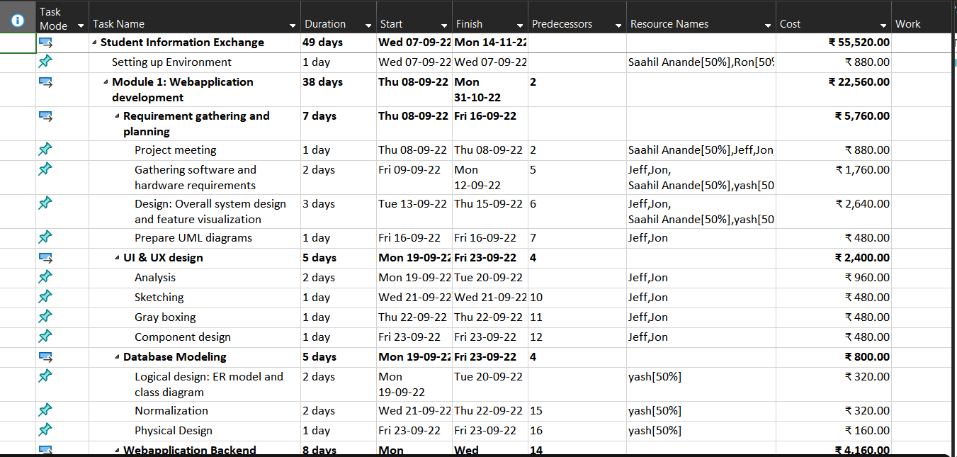

**NON-HUMAN RESOURCES**

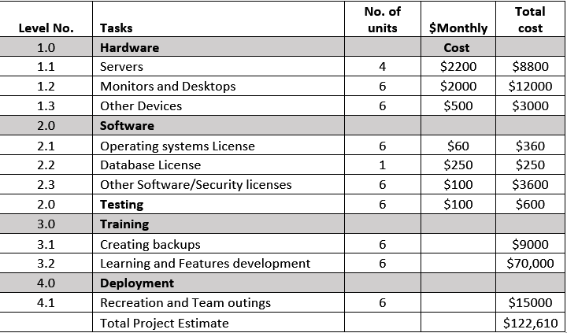

The split up of Human and Non-Human Resources of the above is given as follows:

|  |  |
| --- | --- |
| Human Resources | **$55,520.00** |
| Non-Human Resources | **$122,610.00** |
| Total Cost | **$178,130.00** |

If a profit of 100% is considered for the above cost, then the cost would be **$356,260.00**

* **New Schedule (Duration):**

The New Schedule that has been estimated the COCOMO System Star Demo tool is as follows:

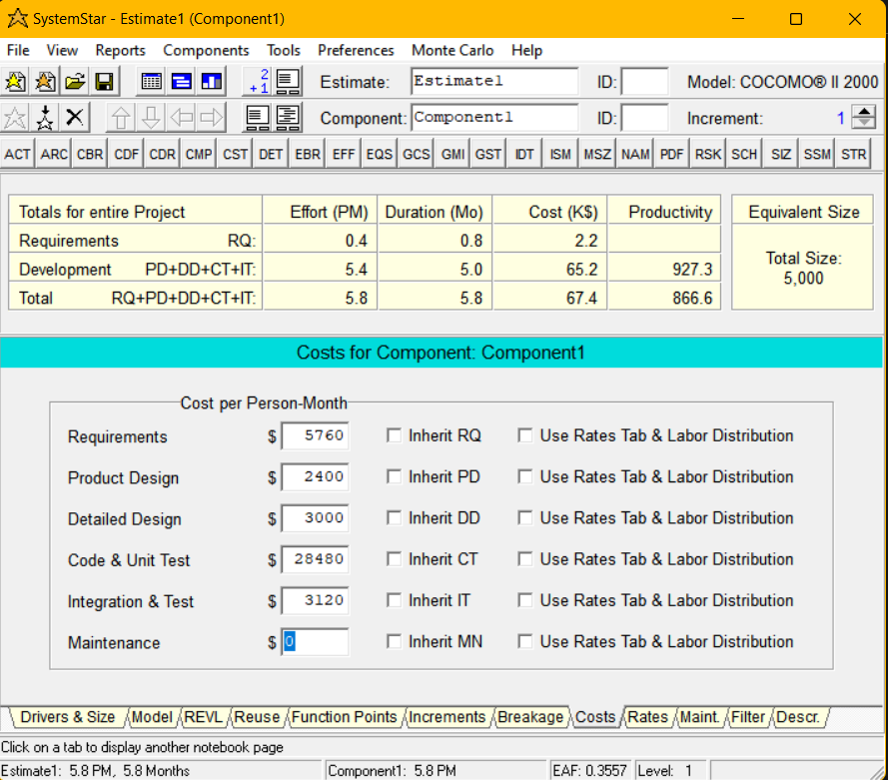

Taking all the cost drivers and scale drivers into account, The project's anticipated cost is **$67,400.00** since, as the tool says

The time frame is predicted to be 5.8 months.

When compared to the earlier MPP-planned duration, this is excessive.

This is because when the plan was designed utilizing MPP, high scale and cost driver values were not taken into account.

* **COCOMO estimated costs (Human Resources):**

The cost estimated by COCOMO for Human Resources is based on two categories.

**Project Manager - $60/hr** & **Others (Developers, Testers, Lead) - $30/hr.**

The cost split up is given below:

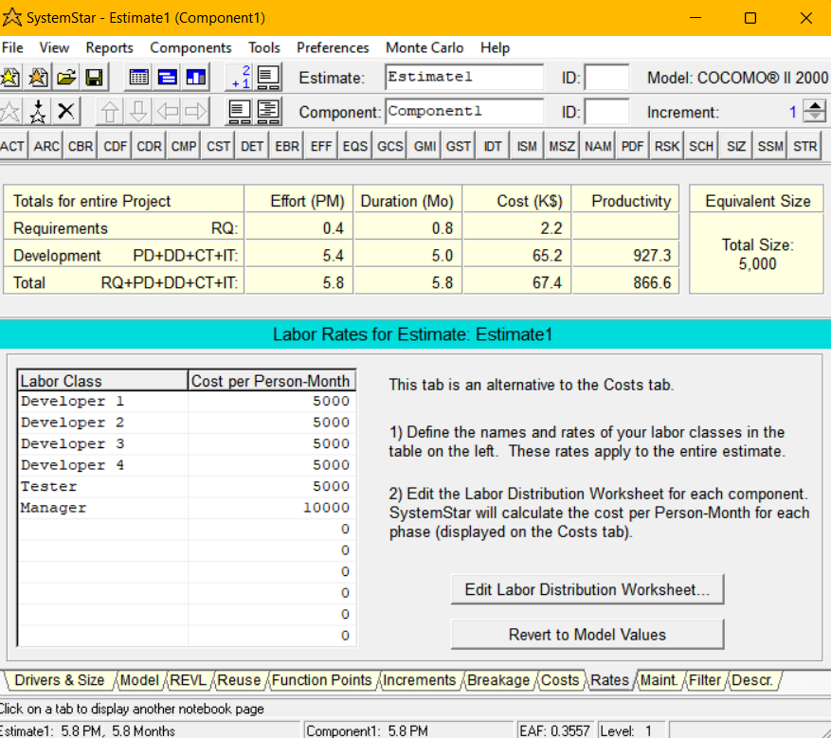

* **Non-Human Resources:**

The Non-Human resources (Material cost) estimated for the project includes the cost of

Monitor and desktop

Operating system licence

Database licences

Hardware

Software

Test Driver

Cloud Server

recreation and team outing

and the total cost is estimated as **$122,610.00**

* **Profit:**

The cost estimate of the project without considering any profit is estimated to be **$67,400.00** + **$122,610.00**= **$190,010.00**. When a new product enters into the market, it is essential to put the clients first to get a hold of the market. Keeping that in mind, we have considered a profit margin of 100%.

Therefore, the profit estimate would be **$190,010.00**

* **Total cost:**

The total cost estimate of the project estimated using COCOMO using System Star Demo tool is **$190,010.00**. With a final profit margin of 100%, the total cost is estimated to be **$380,020.00**

# 4. Conclusion and Recommendations

The below table compares the difference in the cost, work and duration estimates between Microsoft Project Plan estimation and COCOMO II Tool estimation.

|  |  |  |
| --- | --- | --- |
| **Estimation Method** | **Factors** | |
| **Duration** | **Cost** |
| Microsoft Project Plan (MPP) | 1.6 months | **$356,260.00** |
| COCOMO Estimation | 5.8 months | **$380,020.00** |

The final project cost varied significantly depending on whether MPP or COCOMO was used for planning, as shown in the chart above.The COCOMO estimator predicted that the project's costs would be somewhat higher than those predicted by the MPP. The project duration varied significantly, Cocomo estimated that the project will take up to 5.8 months where as we previously calculate it to be around 2 months.

To sum up, in the earlier documentation, we had solely taken into account the project's requirements and the associated human and non-human costs. However, after using COCOMO II, we can see that the development phase includes a lot more components than we initially thought and will cost more than we had anticipated. Even if we use all of our resources, both human and non-human, to the fullest extent possible, the length will be longer than three months, and we will not be able to complete the project in that amount of time.

For the Microsoft Project Plan, the SLOC and the Estimating Model were two components that were not taken into account. The model dictates the project's estimating strategy, whereas the SLOC specifies the size of the project's code. These were taken into account when estimating using the COCOMO approach. Our MPP computation did not take into account factors like CPU execution time, storage capacity, the volume of data trained for the database, the platform being used, the programming expertise of the platform programmers, or other factors.

The COCOMO tool estimated took into account all of the aforementioned elements that MPP overlooked, yielding a precise estimate of the project's length and cost. Some of these components were on the higher side, thus at the end of the estimation, we had a larger cost. The project probably won't be finished in three months, according to the most recent estimates of effort and time. The project is still very profitable, despite the revised estimated cost.

**Recommendation:**

From a technological standpoint, the organization is able to finish this job. It is necessary to discuss the project delivery date. The company must inform the client of the updated COCOMO II cost and schedule and ask them to reevaluate the delivery dates. I would suggest that the board of directors think about expanding the team's resources in order to hasten the project's completion and shorten its overall duration.The sooner the full project is finished, the sooner we can take advantage of all the advantages of the application.

# Appendices

Additional documents, printscreens of COCOMO reports, references.

<https://www.codeproject.com/Articles/9266/Software-Project-Cost-Estimates-Using-COCOMO-II-Mo>

<http://www.agileestimator.com/2020/01/22/cost-drivers-scale-factors/>

<http://www.softstarsystems.com/cocomo2.htm>

<https://www.youtube.com/watch?v=lr0vA_p6T7Q>

<https://arthurdejong.org/cocomo/manual.html>

<https://www.pearsonhighered.com/assets/samplechapter/0/1/3/0/0130266922.pdf>

<http://ranger.uta.edu/~khalili/Overview%20of%20COCOMO.htm>

